Software Requirements Specification
for
Student Portal
Version 1.0 approved
Prepared by Orane Sappleton
The University of Arizona Global Campus
December 16, 2024
Table of Contents
Table of Contents ii
Revision History ii
1. Introduction 1
1.1 Purpose 1
1.3 Intended Audience and Reading Suggestions 1
1.4 Project Scope 1
2. System Features 1
2.1 User Registration 1
2.2 User Profile 2
2.3 User Login 2
2.4 Course management 2
2.5 Course Enrollment 2

Revision History
Name | Date | Reason For Changes | Version
Orane Sappleton | 12/23/24 | Added diagrams and testing types | 1.0

Introduction

Purpose

The purpose of this document is to outline the requirements for a new user registration and course enrollment system. This system will support user account creation, profile management, course listing, and enrollment processes.

Intended Audience and Reading Suggestions

This SRS document is intended for several key stakeholders. Project Managers will use it to understand the scope and requirements of the online learning platform. This will help them manage the project effectively and ensure that all necessary components are included. Developers will refer to this document as a guideline for the development of the platform. It will ensure that all required features and functionalities are implemented correctly, providing a comprehensive framework for the system's build. The Quality Assurance Team will utilize the SRS to create test cases and verify that the platform meets all specified requirements. This ensures the platform's reliability and functionality before it goes live. End Users, including Educators and Students, will provide feedback on the requirements outlined in the document. Their input will help ensure that the platform meets their needs and expectations, making it user-friendly and effective.

Project Scope

This system will facilitate the registration of new users, management of user profiles, and enrollment in online courses offered across three semesters (spring, summer, and fall). It will also handle waiting lists for courses that reach maximum enrollment capacity.

System Features

User Registration
- The system will allow new users to register by creating an account.
- Each new user will create a unique ID and password.
- The system will prevent duplicate user IDs during registration.

User Profile
- Student ID
- Email address
- First Name
- Last Name

User Login
- Registered users will be able to log in to the system using their unique ID and password.

Course Management
- The system will list courses available for each of the three semesters (spring, summer, fall).
- Not all courses will be offered every semester, and the system will reflect this accurately.
- Each course should have a maximum enrollment capacity, which may vary by course.

Course Enrollment
- Users will be able to enroll in available courses.
- Users will be able to cancel their enrollment in any course.
- Upon cancellation, the system will notify the first user on the waiting list (if any) that a spot has become available.

UML Models

Figure 1

Use Case Diagram

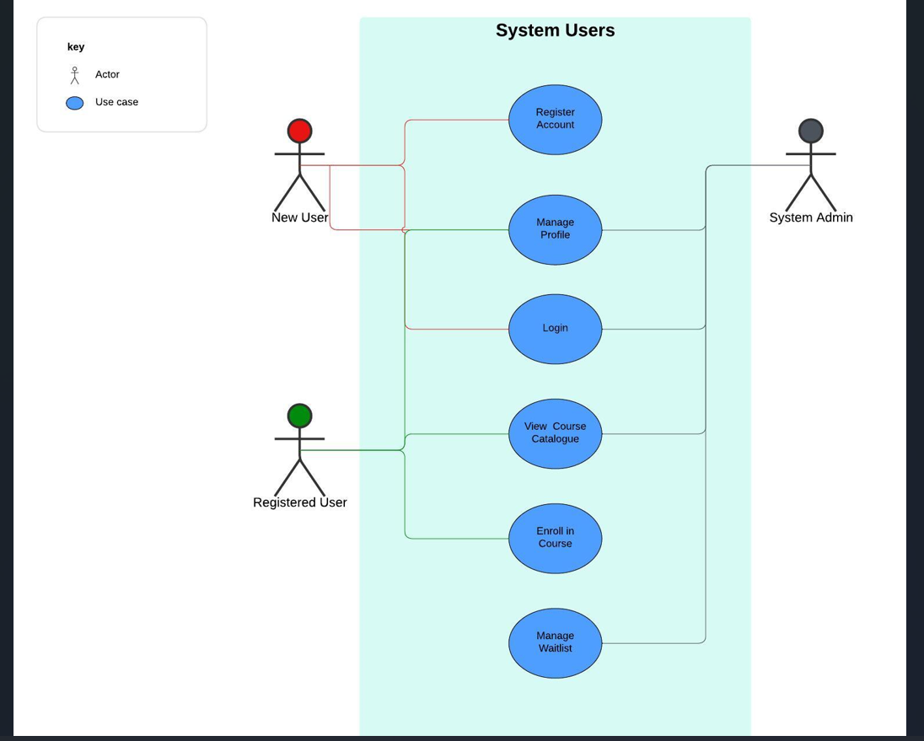

Figure 2
Class Diagram

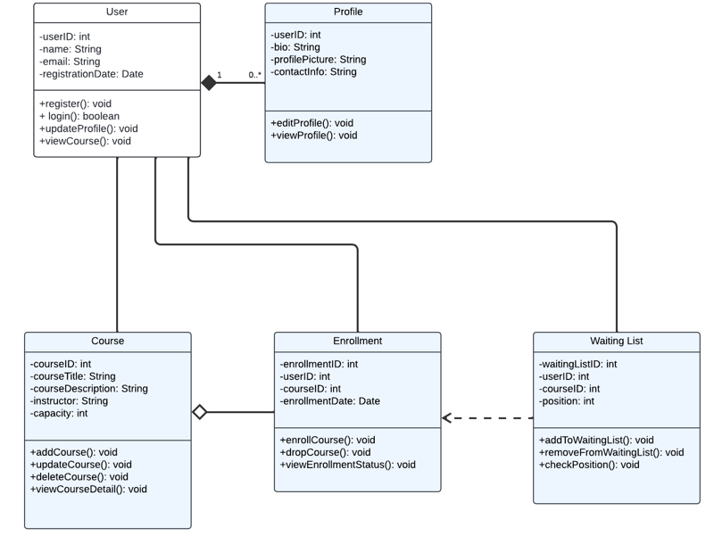

Figure 3

Sequence Diagram
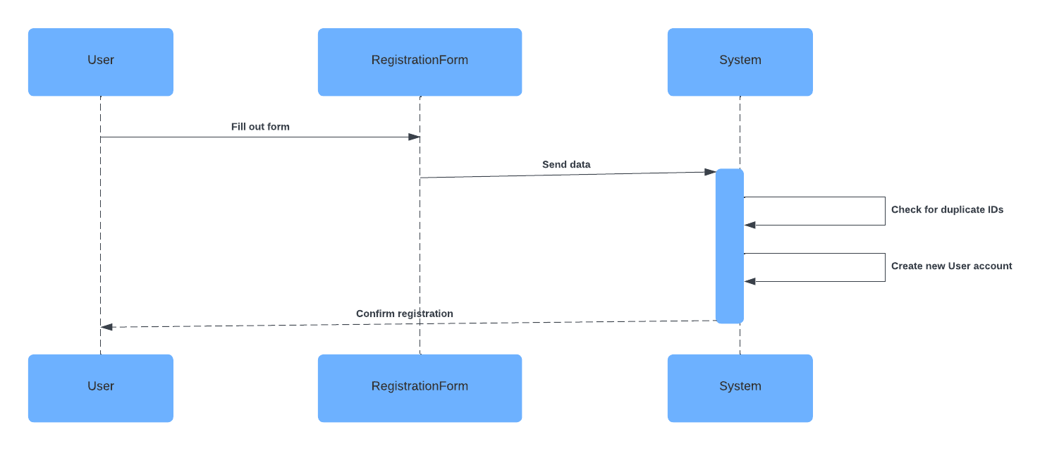

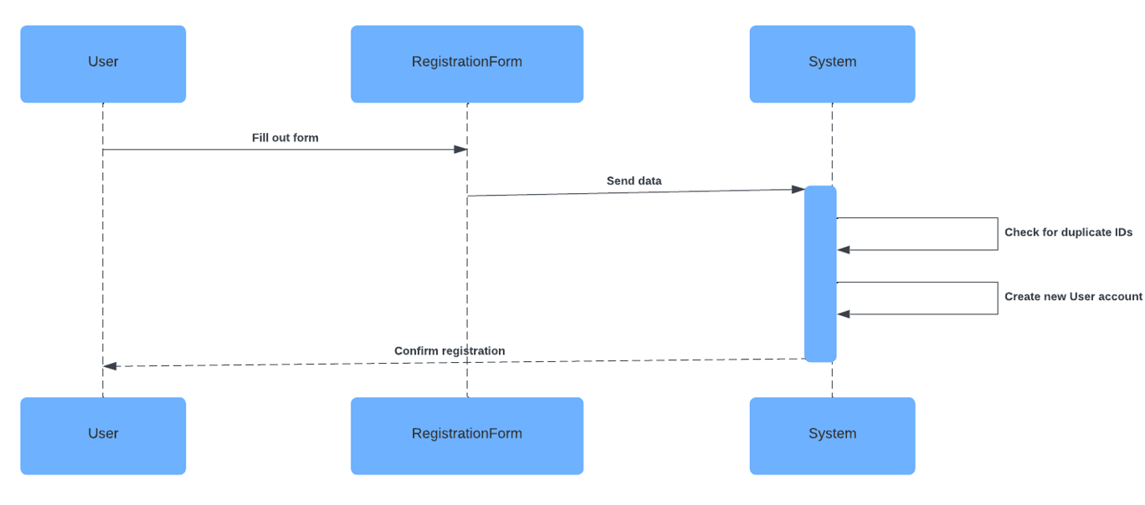

Figure 4

Activity Diagram

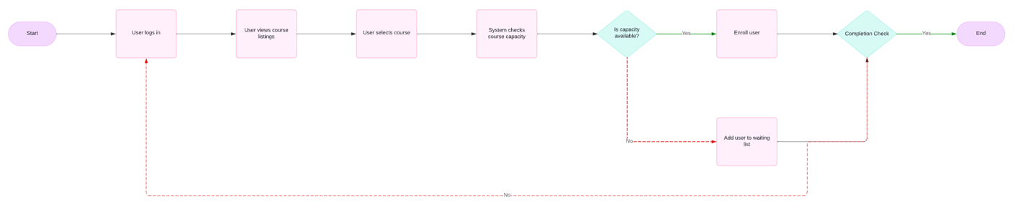

Figure 5

State Diagram
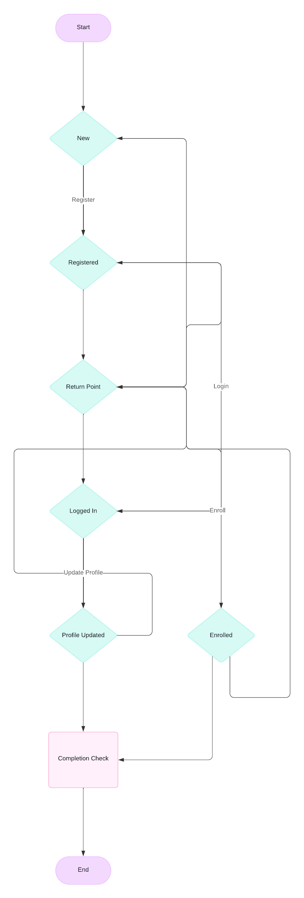

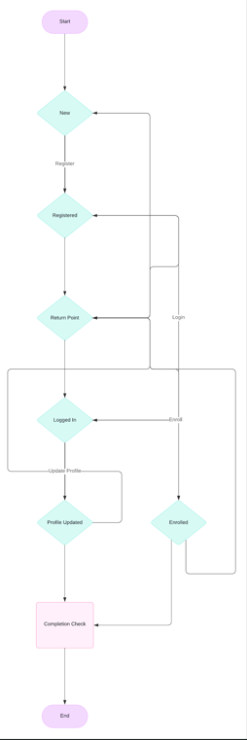

Levels of Testing

Components testing
This level focuses on testing individual components or classes, like the User, Profile, Course, Enrollment, and WaitingList classes, to ensure they function correctly in isolation. “This approach helps identify defects early in the development cycle, saving time and reducing the cost of fixing issues later.” (Devi, 2024, para. 8).

Integration Testing
Here, this step will test the interactions between different components. The article What Is Integration Testing And Its Types? (n.d.) says that integration testing “is to take already-validated parts (by unit testing) and combine them to ensure that the interaction between them works as expected. (para. 5). For example, it needs to verify that the Enrollment class properly interacts with the Course and User classes, ensuring data flows correctly between them.

System Testing
This level involves testing the entire system as a whole. Checking if all components work together seamlessly and if the platform meets the specified requirements and design metrics. “It is the level of software testing performed before Acceptance Testing and after Integration Testing.” (Gill, 2023, para. 1).

Acceptance Testing

Finally, this is where the system is validated against user requirements. This involves actual users to ensure that the platform is user-friendly and meets their needs before it goes live.

References

Devi, K. (2024, December 17). What is Component Testing? (with Examples). BrowserStack. https://www.browserstack.com/guide/what-is-component-testing

What Is Integration Testing And Its Types? (n.d.). Katalon.com; Katalon. https://katalon.com/resources-center/blog/integration-testing

Gill, S. (2023, February 9). System Testing Types, Best Practices and Tools Overview. Www.xenonstack.com. https://www.xenonstack.com/insights/what-is-system-testing

Summarize the key aspects of the SRS document

